Emergent Infectious Influenza Tracking Form: A PSS Project

Alice Gao, Barakemi Precious Julius, Sadia Mukhtar, Thi Xuan Yen Nguyen

7504848, 7935513, 7509086, 7588361

Project Management

MGMT 73450

Sarah Rabb

April 14, 2020

**Table of Contents**

Team Contract 3

Business Case for Project 5

Stakeholder Register for Project 7

Scope Management Plan 9

Changes affecting Cost 9

Changes affecting Timing of Project 9

Changes affecting Quality/Scope of Project 10

Risk Register 11

Communication Management Plan Version 1.0 14

Stakeholder communications requirements: 14

Communications summary: 14

Escalation procedures for resolving issues: 15

Revision procedures for this document: 15

Glossary of common terminology: 16

Gantt Chart 18

Milestones List 23

Issues Log 25

Lessons Learned Report 27

Work-break Down Structure (WBS) 28

References 29

Appendix I 32

Project Status Report Week 1 32

Project Status Report Week 2 33

Project Status Report Week 3 34

Project Status Report Week 4 35

# Team Contract

**March 17, 2020**

|  |  |
| --- | --- |
| **Project Name**: Emergent Infectious Influenza Tracking Form | |
| **Project Deliverable Date:** April 14, 2020 | **Project Presentation Date:** April 21, 2020 |
| **Project Sponsor:** Sarah Rabb | |

|  |  |  |
| --- | --- | --- |
| **Project Team Members’ Names and Sign-off:** | | |
| ***Name*** | ***Date*** | ***Contacts*** |
| Mia Nguyen | March 17,2020 | mianguyenyen1904@gmail.com |
| Precious Julius | March 17,2020 | preciousjulius4real@gmail.com |
| Alice Gao | March 17,2020 | alicegaoglad@gmail.com |
| Sadia Mukhtar | March 17,2020 | sadiamukhtar11@gmail.com |

**Code of Conduct**: As a project team, we will:

* Communicate
* Address the issues
* Ask questions and support each other
* Be accountable

**Participation:** We will:

* Each team member is responsible submitting the status report by their week of choice
* Be present to our online meetings
* Support other team members if they need help
* Ask questions for clarity

**Communication:** We will:

* Meet through zoom at least once in every week
* Communicate through WhatsApp
* Edit project templates through google doc
* Email

**Problem Solving**: We will:

* Listen to all ideas and communicate
* Set an agenda and take meeting minutes
* Divide work between the team members and support each other

**Meeting Guidelines**: We will:

* Submit all the work on time
* Let everyone participate
* Communication
* Time management
* Assign someone to be responsible submitting the final project

**General Communications guidelines:**

* Meet virtually through zoom every week
* Schedule next week’s meeting time at ending of each meeting
* Notes for discussions will be added to meeting notes
* Any issues or general communications outside of zoom will be posted to Whatsapp group chat
* All documents uploaded to shared google drive to collaborate

|  |  |
| --- | --- |
| ***Responsibilities*** | |
| ***Name and Signature*** | ***Deliverables*** |
| Alice Gao | Business case, Stakeholders, Communication plan |
| Precious Julius | Scope & Risk management |
| Sadia Mukhtar | Milestone list, Issues Log, Lessons learned |
| Mia Nguyen | Gantt Chart, WBS |

Schwalbe, K., & Furlong, D. (2017). Healthcare Project Management: with a brief guide to Microsoft Project, Project Professional 2016. Minneapolis, MN: Schwalbe Publishing.

# Business Case for Project

**March 25, 2020**

**Project Name:** Emergent Infectious Influenza Tracking Form

|  |
| --- |
| **1.0 Introduction / Background**  Covid-19 is currently ravaging our worldwide health system and interrupting regular flow of business functions and everyday life. How global health systems respond to the stress of Covid-19 pandemic depends crucially on its speed of testing, isolation protocols, and the information available. But current Covid-19 data is always ongoing- and data quality gathered in this haphazard time is hard to judge. For 2020-2021 the MOHLT has stipulated new reporting guidelines to better track and report incidence of future occurrences for Covid-19, and any other emerging infectious diseases. |
| **2.0 Business Objective**  To create a new Telus PSS Form to track all relevant information for future waves of Covid-19, influenza and or other emerging infectious diseases on a local clinic level. |
| **3.0 Current Situation and Problem/Opportunity Statement**  Current Information gathered on the Covid-19 pandemic is often ongoing. Information gathered on both case fatality and number of cases are often based on incomplete data. By creating holistic means of record, should a second wave of Covid-19 occur we would have better tracking of the disease on the primary care front, and thus better information for decision support in the long run for future epidemics or pandemics. |
| **4.0 Critical Assumption and Constraints**  Critical Assumption is that Covid-19 will have more than one wave and continue to circulate in the future years as future strains to account for. MOHLTC will need better data collection protocols and results for decision support. Necessary funding to cover form creation and implementation on primary care scale will be provided federally and provincially. Time limit for implementation is in the next flu season, which is fall of 2020. |
| **5.0 Analysis of Options and Recommendation**  Following the SMART Analysis, our primary goal is to create a stable, usable and functioning Covid-19 form for Maple Clinic employees within the next five months, to keep track of future Covid-19 patients, testing, and referrals for those that approach the clinic and their outcomes (Kashyap, 2018). We’ll measure our performance with numerous survey’s with key stakeholders on usability before and after the core form creation. Because our client’s secondary goal is to create modifiable form templates that clinicians can use easily, we’re proposing to work with a programmer instead of purchasing the forms from a third-party vendor. Working with stakeholders, will be able to form key relations to expediate future collaborations for customization. |
| **6.0 Preliminary Project Requirements**  Before project launch, liaising with all relevant stakeholders within Maple clinic, Telus EMR representatives, CIHI, and external technical staff is required. Supply chains should be accounted for and running, hopefully without heavy backlog, during summer months, if technical specifications require server or hardware upgrade. |
| **7.0 Budget Estimate and Financial Analysis**  For a minimum of two to three forms, we estimate at minimum ~$5000┼ accounting for coverage of major stakeholder consultation and form creation. Roughly $8500 for all five proposed forms, with secondary forms being more easily customizable by clinical stakeholders or collaboration for future epidemic. |
| **8.0 Schedule Estimate**  Project should take five months to develop fully before going live. After go-live in September, technical support will be available for the first month. KPI measurement on ease of use and utility of form during the third and sixth month of implementation with adjustments if necessary. Project would adjourn a year from project launch. |
| **9.0 Potential Risks.**  The biggest risks are scheduling conflict between stakeholder meetings and delays in supply chain and shipment should technical requirements increase for the clinic. |

Schwalbe, K., & Furlong, D. (2017). Healthcare Project Management: with a brief guide to Microsoft Project, Project Professional 2016. Minneapolis, MN: Schwalbe Publishing.

┼ This number is obtained from rounding the estimated cost of time for stakeholders to meet and/or work for 5 days, based on average salaries of Ontario Nurse, Health Admin, and Programmer, with the addition of server expansion if necessary (Indeed, 2020; PayScale, 2020; Registered Nurses Association of Ontario, n.d.). Actual costs may vary.

Stakeholder Register for Project

**Prepared by:** Alice Gao **Date: March 25,2020**

|  |  |  |  |  |  |
| --- | --- | --- | --- | --- | --- |
| **Name** | **Position** | **Internal/External** | **Project Role** | **Contact Information** | **General Contact Plan** |
| Sara Rabb | Project Sponsor | Internal | Project Supervisor | [srabb@conestogac.on.ca](mailto:srabb@conestogac.on.ca)  phone: 519-748-5220 ext. 3065 | * Weekly reports through email- update on progress * weekly zoom meeting to clarify project stipulation |
| Bretta South | Registered Nurse | internal | Consultant/ end user/ customer | [Bsout@MapleClinic.ca](mailto:Bsouth@MapleClinic.ca)  phone: 519-223-4157 ext. 2768 | * Weekly summary by email * meeting if possible, to consult on workflow and use, and to answer questions (online format currently) |
| Charlie Dane | Administration Clerk | internal | Consultant/ end user/ customer | [Cdane@MapleClinic.ca](mailto:Cdane@MapleClinic.ca)  phone: 519-223-4157 ext. 2326 | * Weekly summary by email * meeting if possible, to consult on workflow and use, and to answer questions (online format currently) |
| Meredith Rain | Clinic Manager | internal | Clinic Administration manager | [Mrain@MapleClinic.ca](mailto:Mrain@MapleClinic.ca)  phone: 519-223-4157 ext. 5272 | * weekly updates within the first month of project launch & go live, discuss as needed for scheduling purposes with internal clinic stakeholders, and ordering. |
| Dr. Ryan Rain | MD/ Clinic owner | internal | Consultant/ Customer/ End User | [Rrain@MapleClinic.ca](mailto:Rrain@MapleClinic.ca)  phone: 519-223-4157 ext.7724 | * Weekly summary by email * meeting if possible, to report status |
| Cassidy Sleeman | CIHI - Data Scientist | external | Consultant/ Regulator | [Cslee@Cihi.ca](mailto:Cslee@Cihi.ca)  phone: 613-241-5543 ext.1642 | * monthly meeting/email if necessary, to clarify questions on stipulations required for new data gathering regulation |
| Bob Mark &  Leon Stain | PSS. Telus Technical & Sales rep | external | Vendor/ Technician | [Bmark@telush.on.ca](mailto:Bmark@telush.on.ca)  [Lstai@teush.on.ca](mailto:Lstai@teush.on.ca)  phone: 514-367-4968 ext.2627  phone: 514-367-4968 ext. 5782 | * monthly call/meeting/email if necessary, to clarify technical requirements for product/ ask any questions about possibilities of support |
| Christine Dou | Programmer | external | Freelancer, Contract | [Cdou@TechMagician.ca](mailto:Cdou@TechMagician.ca)  phone: 583-246-2442 ext. 2368 | * consult with JavaScript programmer via email during the construction/ execution stage. 1:1 in person- weekly. |
| Louis Lebowski | General  Technician | external | Freelancer,  Contract | [LLebo@IBMguy.ca](mailto:LLebo@IBMguy.ca)  phone: 519-531-4218 | * update webserver and database as needed for each interval of testing and go live date |

Schwalbe, K., & Furlong, D. (2017). Healthcare Project Management: with a brief guide to Microsoft Project, Project Professional 2016. Minneapolis, MN: Schwalbe Publishing.

# Scope Management Plan

The Scope Management Plan describes the procedures to follow in the event of scope changes within the project.

### **Changes affecting Cost**

|  |  |  |  |
| --- | --- | --- | --- |
|  | Authorization Level Required For Changes Causing An Increase In Over-all Cost | | |
|  | Less than $3500† dollars | <$7000> | Greater than $7000 dollars |
| Required authorization level | Sara Rabb & Dr. Ryan Rain & Meredith Rain | Sara Rabb & Dr. Ryan Rain & Meredith Rain | Sara Rabb & Dr. Ryan Rain & Meredith Rain |
| Required Documentation | * Written Scope/ Funding Request Change * Signed agreement | * Written Scope/ Funding Request Change * Signed agreement | * Written Scope/ Funding Request Change * Signed agreement |
| Required Communication | * Email, sponsor meeting, | * Email, sponsor meeting, recent reports * Presentation to sponsors | * Email, sponsor meeting, recent reports * Presentation to sponsors |

### **Changes affecting Timing of Project**

†This number is obtained from the estimated cost of time for stakeholders to meet and/or work for 5 days, based on average salaries of Ontario Nurse, Health Admin, and Programmer(Indeed, 2020; PayScale, 2020; Registered Nurses Association of Ontario, n.d.).

|  |  |  |  |
| --- | --- | --- | --- |
|  | Authorization Level Required For Changes Causing A Project Milestone Delay | | |
|  | Less than 7 days | <14 days > | Greater than 14 days |
| Required authorization level | Sarah Rabb & Dr. Ryan Rain & Meredith Rain | Sarah Rabb & Dr. Ryan Rain & Meredith Rain | Sarah Rabb & Dr. Ryan Rain & Meredith Rain |
| Required Documentation | * Written scope/ Time change request form * Signed agreement * Gantt chart | * Written scope/Time change request for * Signed agreement * Gantt chart | * Written scope/ Time change request form * Signed agreement * Gantt chart |
| Required Communication | * Via email, sponsor meeting * Stakeholder group email | * Sponsor meeting * Written report * Email * Stakeholder short meeting | * Group presentation * Sponsor meeting * Written report * Email * Stakeholder meeting |

### **Changes affecting Quality/Scope of Project**

|  |  |  |  |  |  |
| --- | --- | --- | --- | --- | --- |
|  | Authorization Levels For Changes Affecting Project Quality/Scope | | |  |  |
|  | Future Activities | Current Activities | Completed Activities |
| Required authorization level | Sarah Rabb & Dr. Ryan Rain & Meredith Rain | Sarah Rabb & Dr. Ryan Rain & Meredith Rain | Sarah Rabb & Dr. Ryan Rain & Meredith Rain |
| Required Documentation | * Scope change request * Signed agreement. * Record of Milestones, future tasks on Gantt chart, Updates to Project Management document. | * Scope change request * signed agreement * Record of Milestones, tasks on Gantt chart, Updates to Project Management document. | * Scope change request * signed agreement * Record of Milestones, completed tasks on Gantt chart, Updates to Project Management document. |
| Required Communication | * Written report * email * Sponsor meeting * Follow-up short group stakeholder meeting | * Verbal report during relevant meetings. * Email update as confirmation and follow-up * Follow-up group stakeholder meeting | * Verbal report during relevant meetings. * Email update as confirmation and follow-up * Follow-up group stakeholder meeting |

|  |  |  |
| --- | --- | --- |
|  | Authorization Levels For Changes Affecting Project Quality/Scope ... Continued | |
|  | Reduction in Scope/Quality | Enhancements to Scope/Quality |
| Required authorization level | Sarah Rabb & Dr. Ryan Rain & Meredith Rain | Sarah Rabb & Dr. Ryan Rain & Meredith Rain |
| Required Documentation | Scope change request | Scope change request |
| Required Communication | * Sponsor meeting * Meeting with internal stakeholders * Email/ written report   Copyright © 2018, [World Class Productivity Inc](http://www.wcpconsulting.com/).Permission to use or edit these templates is provided on the condition that this copyright statement is not removed. For further information please contact [info@wcpconsulting.com](mailto:info@wcpconsulting.com)  World Class Productivity. (2018). World Class Productivity-Project Management Training, Consulting. Retrieved from wcpconsulting.com: https://wcpconsulting.com/ | * Sponsor meeting * Meeting with internal stakeholders * Email/ written report |

# Risk Register

* may be a combination: Accept, Avoid, Transfer, Mitigate, Escalate, Share, Exploit, Enhance

|  |  |  |  |  |  |
| --- | --- | --- | --- | --- | --- |
| **Risk Event** | **Risk Type (+/-)** | **Risk Probability** | **Risk Impact** | **Risk Response\*** | **Description of Response** |
| 1. Some nurses might refuse training on how to use the form. | -Compliance risk | Low risk probability | Moderate Impact | Avoid, Mitigate | In a situation where some health care workers refuse training, we will educate them and give them more clarity about the new forms and encourage them to take the training and involve them in the workflow process and testing. |
| 1. Risk of putting in the wrong data | -Operational risk | High risk probability | Moderate to High Impact | Avoid, Mitigate | In case a nurse puts in the wrong data, the form will be able to authenticate each field before the form is saved and submitted. |
| 1. Server breakdown | -Operational risk | Low risk probability | High Impact | Avoid | The number of admins will be limited to prevent hackers and the admin accounts will be kept strictly for maintenance purposes and not for general use. This will reduce chances of server overload. |
| 1. Technical issues with missing Patient File | -Operational  risk | Medium-Low risk | High Impact | Transfer, Mitigate | In case there is a situation of a patients’ file missing, first we let the admin side troubleshoot. In the case they accidentally delete a file, we will transfer the issue to the technical staff to determine whether recovery is possible. |
| 5. Funding Change | -/+  Strategic  risk | Moderate to High risk | High Impact | Adapt | If funding for project changes dramatically, we will need to reassess project plan & timelines i.e. we change the number of forms produced, the number people involved in the forms, whether we delay the project or extend it. |
| 6. Hardware Expansion | -/+ Strategic risk | Medium | Medium to High Impact | Accept, Adapt, Mitigate | If hardware specifications in the clinic does not meet needs- depending on funding available- we will drop the number of forms needed to create (i.e. the online screening tool) or expand. This will be determined early on to account for possible supply chain delays due to the current pandemic. |
| 7. Form Expansion | +Strategic Risk | Low to Medium | High Impact | Transfer, Share, Exploit | In case that the form is popular after Go live or discussed before Go live, we may need to duplicate forms for other clinics.  It would change our scope, involve more staff, and require re-evaluation of project plan and implementation. It will extend overall project timelines, but it should not greatly affect launch date in Maple Clinic. If the expansion does affect it, we will have extensive discussion with sponsors before implementation. |
| 8. Future Form Troubleshoot | - Strategic Risk | Low to Medium | Medium Impact | Share, Mitigate | In the case that Covid- 19 is controlled this coming fall, but new epidemics appear in 2021 or beyond. The ideal is to create form templates flexible enough for future use. Currently it is not possible strictly from the clinician side, but it can be achieved in the future through better collaboration between clinicians and technicians. The secondary goal of this project is to build rapport, connections, documentation and processes, so that a task force can quickly come together to create new record formats for the future years down the line. |

Copyright © 2018, [World Class Productivity Inc](http://www.wcpconsulting.com/).  
Permission to use or edit these templates is provided on the condition that this copyright statement is not removed. For further information please contact [info@wcpconsulting.com](mailto:info@wcpconsulting.com)

World Class Productivity. (2018). World Class Productivity-Project Management Training, Consulting. Retrieved from wcpconsulting.com: https://wcpconsulting.com/

# Communication Management Plan Version 1.0

**March 31st, 2020**

**Project Name**: Emergent Infectious Influenza Tracking Form

## **Stakeholder communications requirements:**

* Currently all communications are via distance in accordance to public health policies of social distancing.
* We will transition back to in person support with hard copy versions of documentation as the situation changes.
* Communication should be clear and concise to the best of everyone’s abilities
* This is an open environment facilitating dialogue- zero tolerance of hate speech, prejudice, stereotype and any aggressive or inappropriate behavior.
* Any occurrence of such will lead to one on one consultation and changes as needed, punitive action if warnings are not heeded.
* General organizational workplace policies on anti-harassment and workplace safety will continue to be upheld.

## **Communications summary:**

|  |  |  |  |  |  |
| --- | --- | --- | --- | --- | --- |
| **Title of Stakeholder** | **Stakeholder** | **Type** | **Producer** | **Delivery Method** | **Times and Frequency** |
| Project steering committee | Dr. Ryan Rain, Meredith Rain, Sara Rabb (when available) | Biweekly Status Report | Sadia  Mukhtar,  Alice Gao | Zoom  virtual meeting  digital report/ or Email | Wed. mornings at 10:00 am. |
| Project Sponsor | Sara Rabb | Monthly Status Report | Alice  Gao | Zoom virtual meeting,  digital report attached to Email | First Tuesday of month by 9:00 AM |
| CIHI Consultant | Cassidy Sleeman | Consultation at beginning of project, As needed & at launch | Precious  Julius | Email and or Call, GoogleHangout as needed | First Monday of the Month, based on availability |
| Tech Consultants | Telus:  Bob Mark &  Leon Stain  Programmer:  Christine Dou  General Technician: Louis Lebowski | Weekly Consultation or More as needed | Precious  Julius & Mia Nguyen | Email and or Call, GoogleHangout as needed | First Monday of the Month based on availability.  Regularly twice a week on Tuesdays and Thursdays during form creation |
| Affected employees | All Maple Clinic team members  (Bretta South, Charlie Dane e.t.c.) | Short weekly Status Report | Mia Nguyen | Memo,  Group report Email, announcement at general meetings as needed | Apr 28th & following up weekly |
| Project team | All team members (Bretta South, Charlie Dane e.t.c.) | Weekly Status Report and open discussion | Sadia Mukhtar, Alice Gao,  Mia Nguyen,  Precious Julius | GoTo Meet virtual meeting,  Group follow-up Email | Thursday at 9:00 am |

## **Escalation procedures for resolving issues:**

* De-escalation of verbal conflicts: i.e. listening techniques, mirroring, talking it out.
* Scheduling more meetings for problems that require group input.
* Equal and ASAP delegation of tasks should project scope increase or large risk occurs and problem must be mitigated for future progress.
* Early cross training of key duties in main project if team members need to exit participation due to unforeseen circumstances.
* Identification and regular communication of clinic Stakeholders who can fill major consultation and training roles in similar circumstances.

## **Revision procedures for this document:**

* This document will be revised as necessary. Most likely quarterly and after coronavirus public procedures and isolation protocols change.
* It will be reassessed at project launch in April, June, and early fall before Go-live (August 31st).
* Can be revised as necessary or at staff/ team member/ any project member request.

## **Glossary of common terminology:**

Medical Terminology:

|  |  |
| --- | --- |
| ARDS: | Acute respiratory distress syndrome, or respiratory failure in adults. Symptoms include, difficulty breathing, rapid breaths and blueness of face (Brooks & Brooks, 2014). |
| Asymptomatic carrier: | An individual who acts a reservoir for a pathogen but presents no symptoms and may be able to infect others (Farlex, 2012). |
| Community Transmission: | Source of infection is within the community where contact tracing has not yet been employed and the links between person to person is currently missing (Goverment of Canada, 2020). |
| Comorbidity: | The extent of which two or more pathologies tend to occur simultaneously in a population (Farlex, 2003). |
| COPD: | Chronic obstructive pulmonary disease, a progressive disease the restricts the lung’s airflow, making breathing difficult. Most COPD results from environmental and lifestyle factors such as smoking (Brooks & Brooks, 2014). |
| COVID-19: | New infectious disease caused by a coronavirus strain, first detected in Wuhan, China on December 31, 2019 (World Health Organization, 2020). |
| Dyspnea: | Difficulty breathing (Brooks & Brooks, 2014). |
| Hygiene Protocols: | Any procedure in place related to maintaining hygiene to reduce risks of infection, like handwashing protocols and sanitation practices (Government of Canada, 2020). |
| Immuno compromised: | People who are more susceptible to infections because of a congenital condition, illness, or medication to supress their immune system (Government of Canada, 2019). |
| Influenza: | Highly contagious and severe viral infection of respiratory system (Brooks & Brooks, 2014). |
| Morbidity rate: | incidence of an illness within a population (Brooks & Brooks, 2014). |
| n95 masks: | Respirator/Surgical Mask used to protect user from airborne particles such as liquid droplets (U.S. Food & Drug Administration, 2020). |
| PPE: | personal protective equipment |
| SARS: | Severe Acute Respiratory Syndrome, an infectious disease caused by an earlier type of coronavirus (SARS-CoV) (Government of Canada, 2020). |
| Self-Isolation: | A form of self quarantine, public health Canada recommends 14 days stay at home and avoidance of contact with others, practicing physical and social distancing to protect one’s home and community (Government of Canada, 2020). |
| TIA: | Transient Ischemic Attack characterized by a deficient blood supply to the brain. Symptomatically like a stoke, but usually temporary with complete recovery. TIA often act as warnings of future stroke (Brooks & Brooks, 2014). |
| Virulent Strains: | A group of viruses that are distinct genetically from other groups in the same species (Farlex, 2007). |

Organizational Terminology

|  |  |
| --- | --- |
| CIHI: | Canadian Institute of Health Information |
| IFA: | Immunization Fund of Canada |
| MOHLTC: | Ministry of Health and Long-Term Care |
| PHAC: | Public Health Agency of Canada |

Technological terminology:

|  |  |
| --- | --- |
| *C++/ C #:* | General-purpose object- oriented program language that provides support for component-oriented software engineering principles (ECMA International, 2017). |
| *Database:* | Data held on a computer structured in specific and set ways to reduce error and save space, usually accessible in multiple ways (Lexico, 2020). |
| *JavaScript:* | An object-orienting programing language, commonly used within browsers and the primary language for modifying Telus PSS (Lexico, 2020). |
| *Normalization*: | A process of separating data into structures of related tables, it reduces data redundancy which aids in data storage and maintenance (Murach, 2019). |
| *PSS suite:* | Customizable EMR that was originally created by physicians and is currently still marketed to physicians. Owned by Telus Canada, previously called Practice Solutions (TELUS Health, 2020) . |
| *Python*: | High level interpreting programming language that’s open source (Lexico, 2020). |
| *Servers*: | A computer or computer program which manages access to a central resource in a network (Lexico, 2020). |
| *Web application:* | A program that clients can run in a browser, which sits on the web server (Chafee, 2012). |

Schwalbe, K., & Furlong, D. (2017). Healthcare Project Management: with a brief guide to Microsoft Project, Project Professional 2016. Minneapolis, MN: Schwalbe Publishing.

# Gantt Chart

Our Gantt chart is divided roughly into three parts. The first section is the general timeline for our first Project Management document, where all tasks are coloured blue. The second portion is our plan and task list for actual the process of creating forms in this project, coloured in warm oranges and yellows. The last portion is after product launch, which is for additional updates, gathering feedback and KPI’s; it remains uncoloured. At the end of the Gantt chart are additional notes and instructions for the completion of certain tasks.

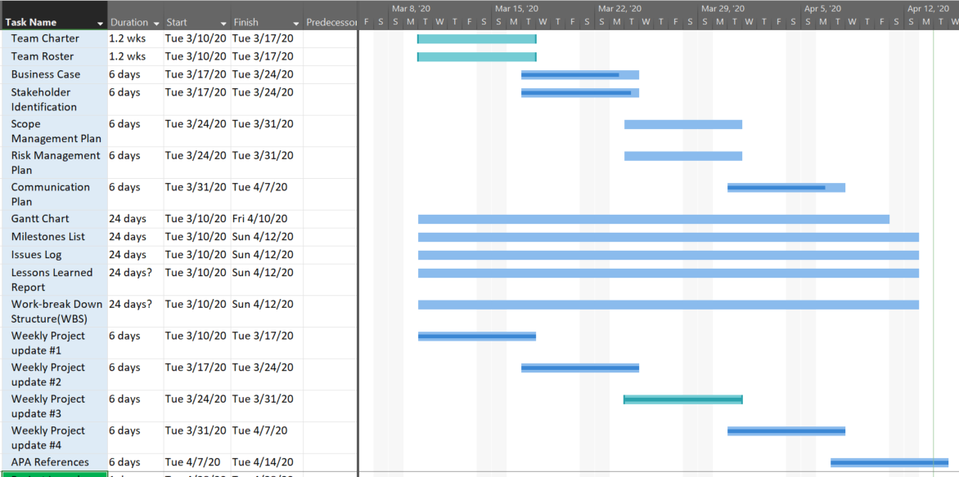

Figure First Section: Project Management Planning. Adapted from Rabb S., 2020, p.51.

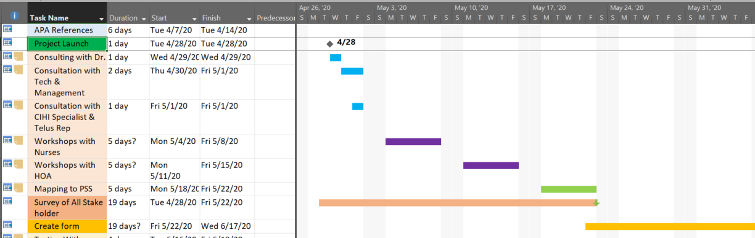

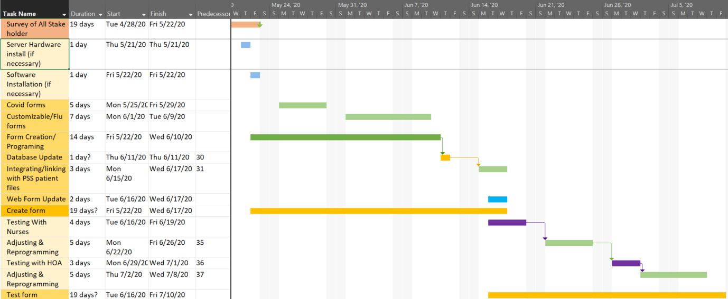

Figure .,3.& 4. Second Section: Process of Creating Forms. Adapted from Rabb S., 2020, p.51.

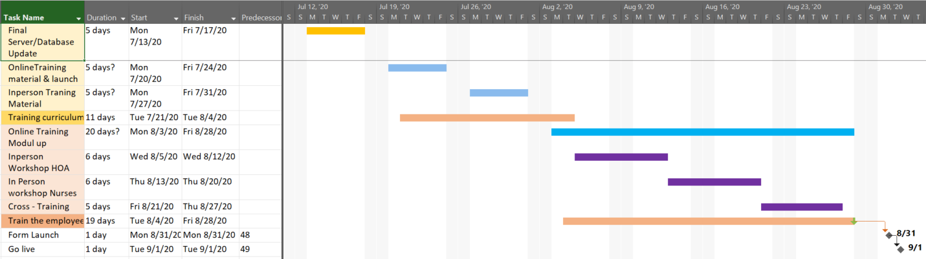

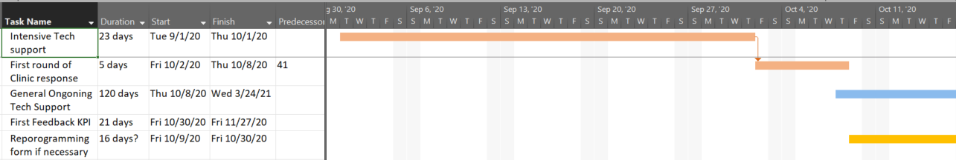

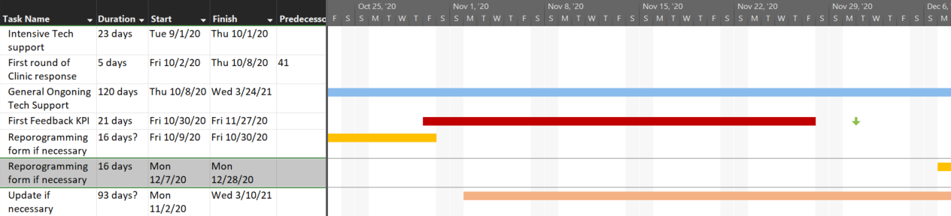

Figure 4. & 5. Third Section: Form Launch and Feedback. Adapted from Rabb S., 2020, p.51.

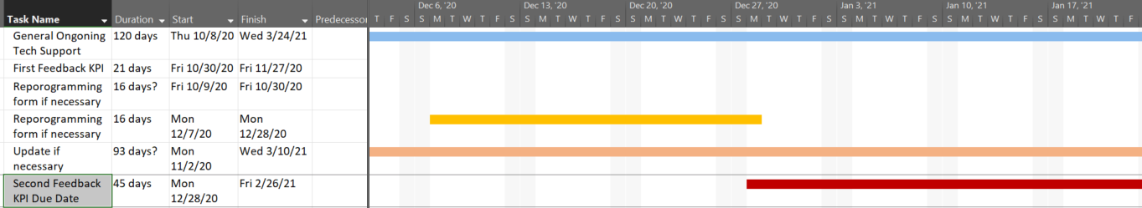

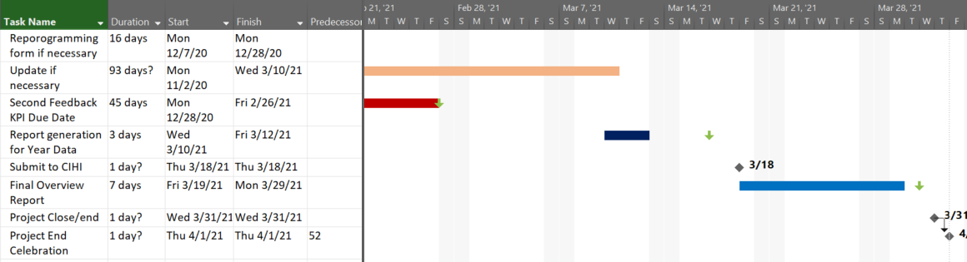

Figure 6. & 7. Third Section Continued: Form Launch and Feedback. Adapted from Rabb S., 2020, p. 51.

**Additional Notes on Timeline:**

*4/29* *Consulting with Dr.*

* Documentation Practices

*4/30-5/01 Consultation with Tech & Management*

* Current tech resources
* Current efficiencies
* Introduce flow diagrams

*5/1 Consultation with CIHI Specialist & Telus Rep*

* Reiterate MOHLTC stipulations
* Questions and concerns to be asked
* Support in implementation
* Dates for in person installation

*5/4-5/8 Workshops with Nurses*

* Includes all nurses
* Detailed Workflow Analysis
* Flow diagrams

*5/11-5/15 Workshops with HOA*

* Includes all Health Office Administrators (HOA)
* Detailed Workflow Analysis
* Flow diagrams

*5/18-5/22 Mapping to PSS*

* Parse most common practices to Form Plan or how the workflow is adapted to digital process - Recommendations or suggestions to changes to workflow

*6/16-6/19 Testing with Nurses*

* Includes all Nurses
* Test Period for all Nurses
* Open to feedback

*6/22-6/26 Adjusting & Reprogramming*

* Editing Form as necessary
* Modifying Server and database update of those changes

*6/29-7/01 Testing with HOA*

* Includes all HOA
* Test Period for all HOA
* Open to feedback

*7/2-7/8 Adjusting & Reprogramming*

* Editing Form as necessary
* Modifying Server and database update of those changes

*11/2-3/10/21 Update if necessary*

* Applies to Forms
* Database tables
* Templates if applicable
* Server

*3/18 Submit to CIHI*

* Completed reports need to be submitted to CIHI

*3/19-3/29 Final Overview Report*

* year in review writeup
* high notes
* lessons learned
* prospective projects related to
* all deliverables for presentation

# Milestones List

|  |  |  |  |  |  |
| --- | --- | --- | --- | --- | --- |
| Milestone Number | Milestone Name | Mandatory/Optional | Deadline for Decision | Date of Occurrence | Verification |
| 1 | Project Planning kickoff meeting | Mandatory | March 9, 2020 | March 10, 2020 | A Project Sponsor Approval |
| 2 | Project Pre Planning start | Mandatory | March 16, 2020 | March 17, 2020 | A Project Sponsor Approval |
| 3 | Complete gathering project requirements | Mandatory | March 23, 2020 | March 24, 2020 | A Project Sponsor Approval |
| 4 | Form/template requirements identified | Mandatory | April 6, 2020 | April 7, 2020 | A Project Sponsor Approval |
| 5 | Project kickoff meeting | Optional | April 24, 2020 | April 28, 2020 | A Project Sponsor Approval |
| 6 | Survey to be completed by the stakeholders | Mandatory | May 1, 2020 | May 15, 2020 | A Project Sponsor Approval |
| 7 | Create the form/template (Number of) | Mandatory | May 15, 2020 | May 22, 2020 - June 17, 2020 | A Project Sponsor Approval |
| 7 | Database updated | Mandatory | June 12, 2020 | June 15, 2020 | A Project Sponsor Approval |
| 8 | Final Design form/template | Mandatory | July 8, 2020 | July 10, 2020 | A Project Sponsor Approval |
| 9 | Project team meeting | Optional | On-going | On-going | A Project Sponsor Approval |
| 10 | Complete testing | Mandatory | July 8, 2020 | July 10, 2020 | A Project Sponsor Approval |
| 11 | Training curriculum developed | Mandatory | July 31, 2020 | August 3, 2020 | A Project Sponsor Approval |
| 12 | Train employees | Mandatory | August 4, 2020 | August 28, 2020 | A Project Sponsor Approval |
| 13 | Go live | Mandatory | August 28, 2020 | September 1, 2020 | A Project Sponsor Approval |
| 14 | Feedback completed by employees 3 -month mark & 6 - month mark | Mandatory | October 30,2020  December 28, 2020 | November 30, 2020  February 28, 2021 | A Project Sponsor Approval |
| 15 | Project end/close | Mandatory | March 9, 2020* | March 31, 2021 | A Project Sponsor Approval |
| 16 | Project team meeting/celebration | Optional | March 31, 2021 | April 1, 2021 | A Project Sponsor Approval |
|  |  |  |  |  |  |
|  |  |  |  |  |  |
|  |  |  |  |  |  |
|  |  |  |  |  |  |
|  |  |  |  |  |  |
|  |  |  |  |  |  |

* All dates on this document are updateable, as the situation changes- deadlines for decisions and completion dates will be change.

Free Project Management Resources. (n.d.). My PM. Retrieved from <https://www.mypmllc.com/project-management-resources/>

Schwalbe, K., & Furlong, D. (2017). Healthcare Project Management: with a brief guide to Microsoft Project, Project Professional 2016. Minneapolis, MN: Schwalbe Publishing.

# Issues Log

|  |  |  |  |  |  |  |  |  |
| --- | --- | --- | --- | --- | --- | --- | --- | --- |
| Issue # | Description of Issue and Impact on the Project | Priority (L/M/H) | Date Reported | Reported By | Assigned To | Status | Date Resolved | Resolution/Comments |
| **1** | School closure project members were not able to meet face to face and get access to the school resources | Hight | March 13 | Project sponsor | Team Members | Closed | March 16 | Team members and project sponsor did figure out a way to work on the project virtually |
| **2** | Planning had an impact on our project at the beginning since we had to redesign project schedule and meeting virtually | Medium | March 17 | Team members | Team members | Closed | March 19 | Team members had met virtually and came up with different ideas to complete the project planning.  Project team decided to use tools for planning example Gantt charts. Team Collaboration |
| **3** | Time management finding the time to meet with project team members while working other projects | High | March 17 | Team members | Team members | Open |  | Team working together to find the time that works for everyone |
| **4** | Risk Management this can have an impact on our project and can cause the project to fail | Low | March 31 | Team members | Team members | Closed | March 31 | Although was impossible to predict every potential risk but project team had strategic planning and collected information beforehand and with that were able to develop control measures that can deal with risks |
| **5** | Finding the right project management template | Low | March 31 | Sadia | Sadia | Closed | March 31 | Team had a meeting with the project sponsor about the project templates to be used |
| **Issues Discussed To be Addressed During Implementation** | | | | | | | | |
| **6** | Resources/Supply: All materials and resources required may not be available | Medium | March 17 | Team members | Team members | Open |  | Project team members use the online library resources available |
| **7** | Schedule a task of creating the form to be available and to be going live at the end of this year may be delayed to next year | High | March 31 | Alice | Team members | Open |  | Due to the different situations project team will work together to deliver the task on time |
| **8** | Technical issues | Medium | March 17 | Team members | Team members | Closed | March 31 | If the server dies/ computer becomes inaccessible/ PSS suit is updating and non-functional to have Paper version available of each form |
| **9** | Security issues: If system has to be hacked before going to live or viruses will impact our project because there will be no privacy | high | March 31 | Mia | Team members | Open |  | Hiring programmer and IT specialist. install antivirus software and educate and training the employees |
| **10** | Data quality issue: to not be able to have the right information to be collected in the form will impact the project because the usability of the form will be low | Medium | March 31 | Precious | Team members | Open |  | To collect the right information since the form is new. To avoid creating duplicate data and to upgrade once in every 6 months. |
|  |  |  |  |  |  |  |  |  |

Schwalbe, K., & Furlong, D. (2017). Healthcare Project Management: with a brief guide to Microsoft Project, Project Professional 2016. Minneapolis, MN: Schwalbe Publishing.

# Lessons Learned Report

**Project Success**

**Project planning:** This stage of the project went well because the team members were able to schedule regular meetings and share ideas. Team members were also able to determine how the project scope would be defined, validated, and controlled.

**Understand the scope:** This stage went well because the project team worked together in order to achieve project’s objectives and goals.

**Document and prioritize tasks**: The project group has used project management templates to document tasks, team members were also able to meet with the project sponsor to ensure that they had understood the tasks and have prioritized them appropriately.

**Project status reports:** The team understood project status throughout the project lifecycle. Each member was involved and had created project status report weekly which had included accomplishment, issues and challenges, and future plans for each week.

**Communication:** The group decided what form of communication worked best. Team members were able to meet and communicate regularly, exchange ideas, knowledge and experience. Project members showed respect and have supported each other.

**Wrap up the project:** All tasks have been completed on time. Project team were satisfied with the outcome, and the team were able to talk about the success and failures throughout the project.

**Project Challenges**

**Time management:** Finding the time that works for each of the teammate to meet while working on other projects.

**School closure/working from home:** Project team members were not able to meet face to face and access school resources. Another challenge was finding a quiet workspace from home to work on the project, while other family members were also working from home.

**Technical issues:** Experiencing slow internet speed while working on the project digitally. Distance collaboration across different vendors was difficult (i.e. Google Drive suite. V.S. Microsoft Office). Deliberating between different presentation options was also a repeated discussion point.

# Work-break Down Structure (WBS)

Note: The light-colored boxes represent items that Project Management team are not directly overseeing but must account for.

Additional Fundraising & some Purchasing for e.g. is managed by Maple Clinic Staff and Associates

Figure 9. Telus PS Forms Work-break Down Structure, Adapted from Rabb S.,2020,p.26.

# References

Brooks, M. L., & Brooks, D. L. (2014). Exploring Medical Language, A Student-Directed Approach, 9th Edition. Sr. Louise: Elsevier.

Chafee, A. (2012, May 4). What is a web application (or "webapp")? Retrieved from jGuru: http://www.jguru.com/faq/view.jsp?EID=129328

ECMA International. (2017). C# Language Specification. https://www.ecma-international.org/publications/files/ECMA-ST/ECMA-334.pdf: ECMA International.

Farlex. (2003). Comorbidity. Retrieved from Miller-Keane Encyclopedia and Dictionary of Medicine, Nursing, and Allied Health, Seventh Edition.: https://medical-dictionary.thefreedictionary.com/comorbidity

Farlex. (2007). strains. Retrieved from The American Heritage® Medical Dictionary: https://medical-dictionary.thefreedictionary.com/strains

Farlex. (2012). Asymptomatic carrier. Retrieved from Medical Dictionary for the Dental Professions: https://medical-dictionary.thefreedictionary.com/asymptomatic+carrier

Free Project Management Resources. (n.d.). My PM. Retrieved from https://www.mypmllc.com/project-management-resources/

Government of Canada. (2019, November 1). Immunization of immunocompromised persons: Canadian Immunization Guide. Retrieved from Canada.ca: https://www.canada.ca/en/public-health/services/publications/healthy-living/canadian-immunization-guide-part-3-vaccination-specific-populations/page-8-immunization-immunocompromised-persons.html

Government of Canada. (2020, April 11). Coronavirus disease (COVID-19): Prevention and risks. Retrieved from Canada.ca: https://www.canada.ca/en/public-health/services/diseases/2019-novel-coronavirus-infection/prevention-risks.html

Government of Canada. (2020, April 14). Epidemiological summary of COVID-19 cases in Canada. Retrieved from Canada.ca: https://www.canada.ca/en/public-health/services/diseases/2019-novel-coronavirus-infection/health-professionals/epidemiological-summary-covid-19-cases.html

Government of Canada. (2020, January 21). Severe Acute Respiratory Syndrome (SARS). Retrieved from Canada.ca: https://www.canada.ca/en/health-canada/services/healthy-living/your-health/diseases/severe-acute-respiratory-syndrome-sars.html

Indeed. (2020, April 3). Computer Programmer Salaries in Ontario. Retrieved from Indeed.com: https://ca.indeed.com/salaries/computer-programmer-Salaries,-Ontario

Kashyap, S. (2018, May 1). S.M.A.R.T Goal Setting Practices for Project Managers. Retrieved from ProofHub: https://www.proofhub.com/articles/smart-goal-setting-examples-for-project-managers

Lexico. (2020). Database| Definition of Database. Retrieved from Lexico: https://www.lexico.com/en/definition/database

Lexico. (2020). JavaScript| Definition of JavaScript. Retrieved from Lexico: https://www.lexico.com/en/definition/javascript

Lexico. (2020). Python| Definition of Python. Retrieved from Lexico: https://www.lexico.com/en/definition/python

Lexico. (2020). Server | Definition of a Server. Retrieved from Lexico: https://www.lexico.com/en/definition/server

Murach, J. (2019). Murach's MySQL 3rd Edition. Fresno: Mike Murach & Associates, Inc.

PayScale. (2020, February 16). Average Medical Office Administrator Hourly Pay in Toronto, Ontario. Retrieved from PayScale: https://www.payscale.com/research/CA/Job=Medical_Office_Administrator/Hourly_Rate/99dcb551/Toronto-ON

Rabb, S.(2020).Week 4.[PowerPoint slides].Retrieved April 12, from econestoga.

Registered Nurses Association of Ontario. (n.d.). Dollars and Sense: What are nurses paid? Retrieved March 30, 2020, from Careers in Nursing: http://careersinnursing.ca/new-grads-and-job-seekers/find-nursing-job/dollars-and-sense-what-are-nurses-paid

Schwalbe, K., & Furlong, D. (2017). Healthcare Project Management: with a brief guide to Microsoft Project, Project Professional 2016. Minneapolis, MN: Schwalbe Publishing.

TELUS Health. (2020). PS Suite EMR. Retrieved from TELUS Health: https://www.telus.com/en/health/health-professionals/clinics/ps-suite

U.S. Food & Drug Administration. (2020, April 05). N95 Respirators and Surgical Masks (Face Masks). Retrieved from FDA: https://www.fda.gov/medical-devices/personal-protective-equipment-infection-control/n95-respirators-and-surgical-masks-face-masks

World Class Productivity. (2018). World Class Productivity-Project Management Training, Consulting. Retrieved from wcpconsulting.com: https://wcpconsulting.com/

World Health Organization. (2020, April 13). Rolling updates on coronavirus disease (COVID-19). Retrieved from World Health Organization: https://www.who.int/emergencies/diseases/novel-coronavirus-2019/events-as-they-happen

# Appendix I

## **Project Status Report Week 1**

Sadia Mukhtar

**Team Members:**

1. Thi Xuan Yen Nguyen
2. Alice Gao
3. Barakemi Precious Julius
4. Sadia Mukhtar

**Project Status Summary:** 20% of the project is complete

|  |  |  |  |  |
| --- | --- | --- | --- | --- |
| Scope | Success | Challenges | Project progress | Risks |

**Project Scope**: A form to capture details for preventative measures and the event of a future influenza outbreak at a family MD clinic for 2021.

**Project Success:** This week we were green because we were able to connect and work together through zoom meeting and through WhatsApp. One of our team members had spoked with our project sponsor and we were able to reach a clarity for our stakeholders and business case. Secondly, we were able to complete the work planned for this week. Also, we have all supported each other and came up with ideas of how we can complete our project even if school is closed.

**Challenges:** This week we were yellow which means we had to face some challenges. Since the school was closed this week we had to meet through zoom where we had to figure out time that works for everyone, another challenge was that we were not able to meet with our project sponsor face to face. To overcome from these challenges this week we have decided to meet with our team members at least once in every week that works for everyone.

**Progress on project:** The schedule went off 25% behind because of the school closure but at the same time we were able to accomplish and do some. Our plan was to complete at least 4 templates before Tuesday class this week, but we were able to complete two of them. This will be correct by coming weeks since we have decided the ways to meet virtually, and by working all of us together and supporting each other.

**Risks:** This week there has been only one risk which was the Schedule Risk, the risk that our activities and tasks to be completed this week will take longer than expected because of the school closure. We were able to mitigate this risk by the communication frequency between team members, by clarifying the requirements and having plans.

**Work Planned to be completed this Week:**

* + Team Charter/Team Roster
  + Business Case
  + Stakeholder Identification

**If completed to start working the next steps of the project.**

## **Project Status Report Week 2**

**Alice Gao**

**Team Members**

|  |  |  |  |
| --- | --- | --- | --- |
| Alice Gao | Sadia Mukhtar | Thi Xuan Yen Nguyen | Barakemi Precious Julius |

**Project Status Summary:** 27% of project is Completed

|  |  |  |  |  |
| --- | --- | --- | --- | --- |
| Successes | Challenges | Project Progress | Risks | Timelines |

**Successes**

Originally the plan was to have everything shared by everyone since there was a need to discuss many proponents. While the discussions are still important and ongoing, we’ve decided to divide up the deliverable pieces properly to each team member as the Most Responsible Person for said item, of which we’ll review together as we go along and before the final team meeting.

Timelines have also been better established, both real time in the project (April 14th for hand in, Apr 21st for group presentation) and overall project timeline (see below). Our agreed upon strategies for the final presentation are utilizing PowerPoint through Zoom with each team member taking turns to discuss content.

**Challenges**

Finding time to discuss for our project continues to be a challenge between all our different schedules. We’re properly into the first week of all our classes through virtual means, keeping track and organized between different teacher meetings and group meetings is more confusing than initially anticipated.

Stress levels are also an area we have to work on. This week, we’ve found it difficult to separate work and downtime as well as adjusting to home work spaces. More people are now confined together, everyone has their own schedule means more noise distractions and higher difficulty to concentrate (i.e. Someone playing their music too loud, cooking, etc while another person is conferencing). Everyday tasks outside that used to be normal are now more stressful/anxiety inducing, i.e. it can be difficult to maintain the 3-6 ft social distancing when the grocery store is busy. But all of these challenges can be met with proper management and communication to those around us

**Project Progress**

Both the Stakeholder Identification and the Team charter is done. The actual Business Case document is 20% done, and will be completed by end of the week. We’ve covered ground however in figuring out which way we’ll share specialized files (i.e. Gantt chart in Excel + google drive), and found sample charts related to our project.

**Risks**

Since we had some delay scheduling the meeting for this week. We ended off today’s meeting with an agreed upon time and date for the next one (March 31 @ 2:00pm-3:00pm). Should something come up in the following days, we’ll have a bit more time to communicate reschedule through whatsapp chat.

**Timeline Plan for Project**

Planned project implementation is between now and the end of August. After the proposal presentation in Apr. 21st, Stakeholder consultations, meetings, workshops, training, form creation, installation and execution will take place over the next 5 months with revisions as necessary. Go live is September 1st, 2020, and form use will continue over the annual flu season into next spring with relevant support provided during 1st month, and KPI gathering in March 2021.

**Work planned to be completed this week:**

● Scope Management Plan,

● Risk Management Plan

● Communications Plan

**If completed, each member works on their next step of the project.**

Thi Xuan Yen Nguyen

## **Project Status Report Week 3**

**Team Members:**

1. Thi Xuan Yen Nguyen

2. Alice Gao

3. Barakemi Precious Julius

4. Sadia Mukhtar

**Project Status Summary:** 50% of the project is complete

|  |  |  |  |  |
| --- | --- | --- | --- | --- |
| Scope | Success | Challenges | Project Progress | Risks |

**Project Scope:** To create a form to capture details in the event of a future influenza outbreak at a family MD clinic for 2021.

**Successes:** This week using WhatsApp as our main communication tool we have a meet on time, right before class. We also got in touch with Sara about answering any further questions. We Download of project management software because we found the software is very helpful with the template that is available.

**Challenges:** Meeting ran a little over and we missed the first 2 minutes of Sara’s presentation(class). We might not be able to do zoom presentation due to the over load of zoom and the current situation (presentation plan might change).

**Project Progress:** Current in Progress Scope Management Plan is 20% done, the Business Case 25% done and the Communication Plan 60% done. We started on the Communications Plan, Scope Management Plan, Risk Management Plan, Work breakdown structure. We discussed on Issues log & Milestones list, Gantt chart, Risk Management.

**Risk:** Due to the overload of Zoom our presentation possible different ways to present. There is other option that we came up with like recording our presentation on PowerPoint presentation or record it during our weekly zoom meeting.

**Work planned to be completed this week:**

* Gantt chart
* Milestones List
* Issues Log

**If completed, each member works on their next step of the project.**

Precious Julius

## **Project Status Report Week 4**

**Team Members:**

1. Thi Xuan Yen Nguyen

2. Alice Gao

3. Barakemi Precious Julius

4. Sadia Mukhtar

**Project Status Summary:** 70% of the project is complete

|  |  |  |  |  |
| --- | --- | --- | --- | --- |
| Scope | Success | Challenges | Project Progress | Risks |

**Project Scope:** To create a form to capture details in the event of a future influenza outbreak at a family MD clinic for 2021.

**Successes:** Thisweek we scheduled a zoom meeting on Tuesday 7th of April at 12 noon. The meeting lasted for an hour and 30 minutes. This is because some group members had other zoom meetings scheduled for 2pm so the meeting was cut short. However, we were able to complete 70% of the project deliverables and managed to clarify with Sara about the milestones list and the issue log. Another area of success we encountered is the area of presentation style; the group came to a consensus to make the presentation by doing a video recording during our zoom meeting where every group member will present and the recorded session will be submitted and April 21st will be a question and answer session.

**Challenges:**

This week, minor challenges were faced. We had difficulty working with Microsoft project as well as collaborating through Microsoft suit. Furthermore, there was also a schedule conflict, in that the zoom meeting which was initially scheduled to last for two hours, only lasted for an hour and 30 minutes. This was due to the fact that some group members had another meeting that was scheduled for 2pm.

**Project Progress:** Current progress in deliverables are; Scope Management Plan which is 50% done, the Business Case 80% done and the Communication Plan 60% done, the milestones list is 50% done, the issues log is 70% done and the Gantt chart is 40% done. Furthermore, we have started working on the Work breakdown structure, the communications plan, the risk register, the scope management plan as well as the lessons learned report. To get the meeting started, we talked about the Gantt chart, the issues log and the milestones list.

**Risk:** In terms of risks, we have gone through a series of possible questions that we might run into as we finish our deliverables, possibly what might go wrong in meeting the deadline. For example, working with Microsoft project in completing the Gantt chart.

**Work planned to be completed this week:**

* Finishing up the WBS.
* Finishing up the lessons learned report.
* Completing all deliverables and making sure they are all formatted correctly.

**If completed, each member works on their next step of the project.**